Written by: Matthew Axell

axelleagle@gmail.com

Evaluated by: Gerry McElroy

gerry@wholesalecarparts.com.au

Abstract

This describes the agreed upon functional requirements of the webapp WCP Research Tool. It has been evaluated and confirmed. This can be subject to change.

WCP Research Tool

Functional Requirement Document

Table of Contents

1 About the tool 2

2 Workflow 3

3 Product Map 4

4 Requirements 5

4.1 Login Page 5

4.2 Tab Manager 6

4.3 Dashboard Tab 7

4.4 Product Tab 8

4.5 Stats Tab 10

4.6 Cost and Volume Tab 12

4.7 Alternate Index Detail Tab 13

4.8 Ebay Compatibility Tab 14

5 Future Requirements 15

5.1 Import/Export Tool 15

# About the tool

The WCP Research tool is a website application that is design to help employees of WCP to keep track of past, current, and future research progress on WCP’s product, which is primarily vehicle’s parts.

This is made to ease employees’ process when starting new research on a product. The employee may search up potential product in the web-app to see if said product has been researched before by another employee. An employee could update data on existing products on their IC number, as well as insert new supplier to a product if an employee found one.

The web application has the functionality to export the data shown as a xlsx file that then can be used in other applications. The web application has the other functionality to import data into the system using a xlsx or csv file format.

# Workflow

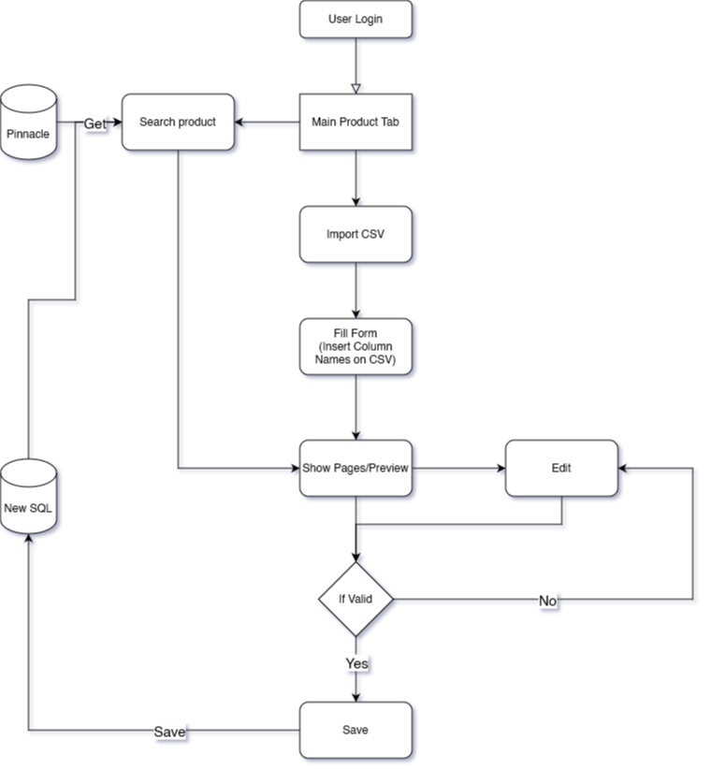  
Web application basic workflow

# Product Map

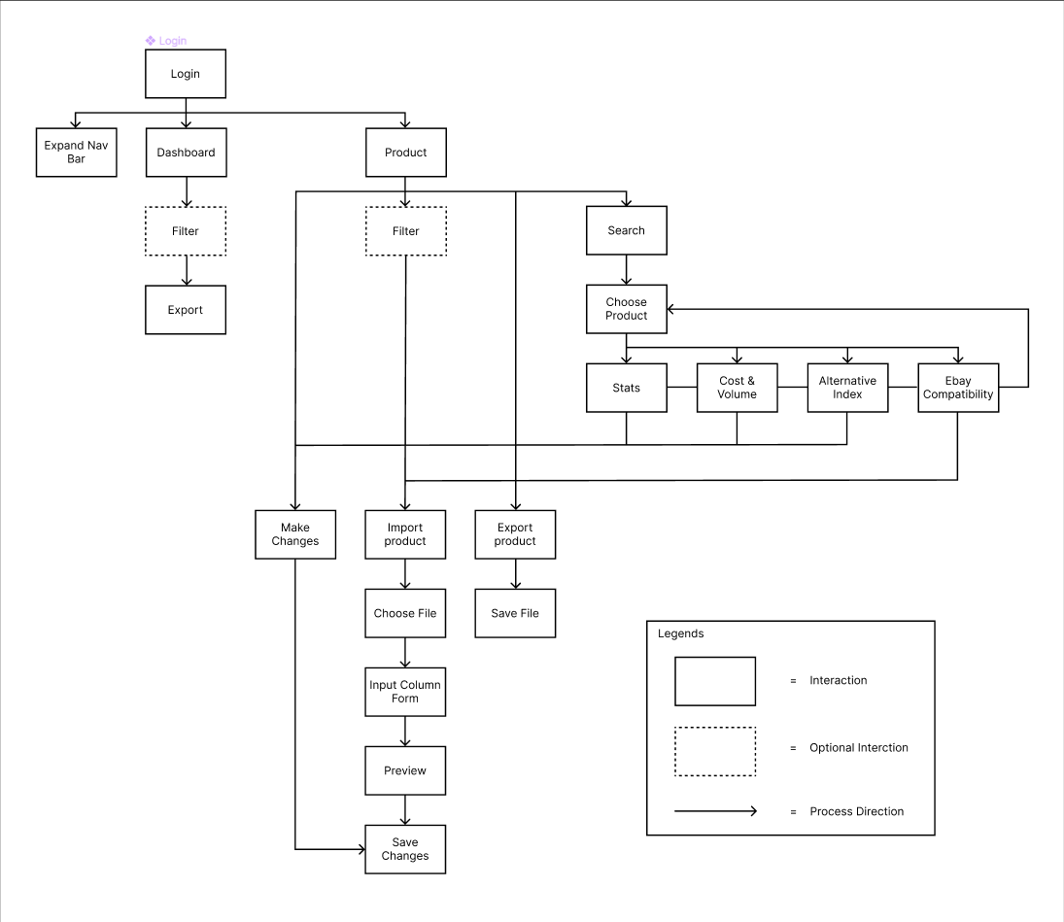

Product Map

# Requirements

## Data requirements

Product relationships:

* Product : Supplier => many to many
  + One supplier will be specially marked as main supplier in the DB for each product.
* Product : OEM => one to many
* Product : VIN => one to many
* Research Number => one to one (required, similar to id)
* WCP SKU => one to one (nullable) (import from Pinnacle, or generated if new and finished research)
* User responsible => one to one (nullable)

Research Number Relationship:

* Status: one to one
* Aftermarket/Genuine OEM : one to one
* Notes: one to one

(More to come)

## Login Page

Login Page Rough Mock Up Design version 2.1

The Login Page will be the page where users will sign into the web application, this is made so that any products researched and updated by the user will be recorded and accounted for.

* Accounts will be managed by the custom software program workflow (not sure of the name yet)
* Need to know about where I can access this workflow accounts and their information.

## Tab Manager

Tab Manager Rough Mock Up Design version 2.1

The tab manager is a menu tool that lets the user navigate around the web application with ease. The tab icons will be changed to a more user-friendly icon as well as grouped according to functionality. The final result will have this manager, albeit the design may be tweaked a bit to improve user experience and user friendliness.

## Dashboard Tab

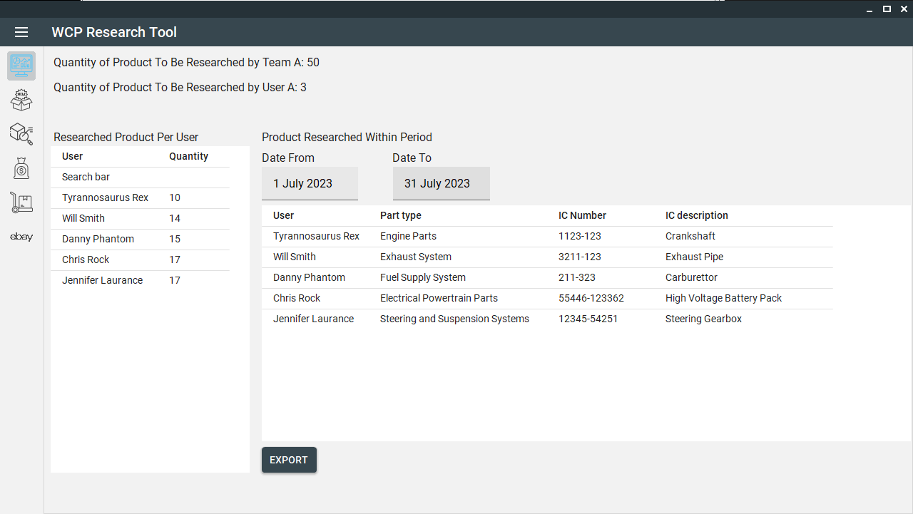

Dashboard Tab Rough Mock Up Design version 2.1

* Ability to export the Product that has been researched within a given period (default to the last 30 days)

## Product Tab

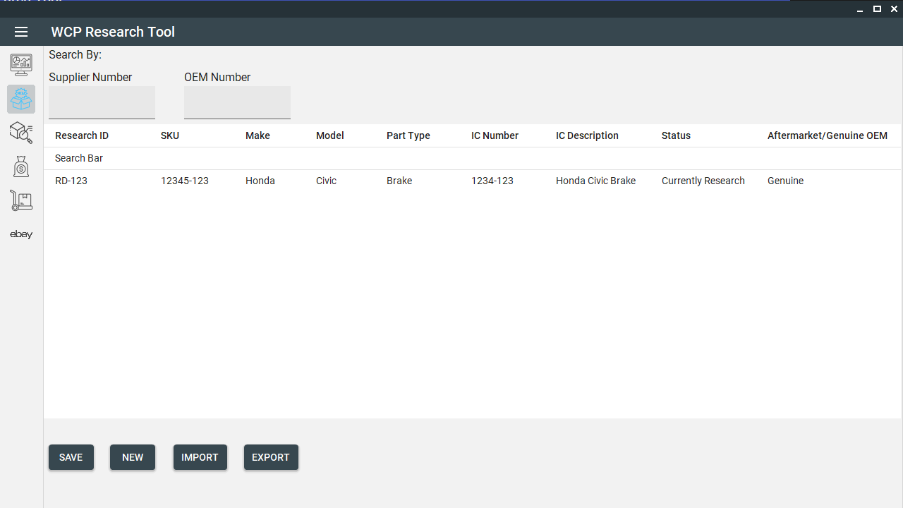

Product Tab Rough Mock Up Design version 2.1

|  |  |  |  |  |
| --- | --- | --- | --- | --- |
| **Column Name** | **Importable** | **Editable** | **Source** | Note |
| Research number | N | N | Generated | May be replaced with Research SKU (Not reco) |
| WCP SKU | N | N | Pinnacle | Blank while being researched |
| Make | N | N | Pinnacle |  |
| Model | N | N | Pinnacle |  |
| Part Type | N | N | Pinnacle |  |
| IC # | N | N | Pinnacle |  |
| IC Description | N | N | Pinnacle |  |
| Status | N | Y | Manual | Muti-select dropdown input |
| Aftermarket/Genuine OEM | N | Y | Manual | Muti-select dropdown input |

Table of Column in Product Tab

* Able to filter the table by:
  + Each Column
  + Supplier Number
  + OEM Number of the products
    - Searching OEM will be searched as though the OEM does not have any symbols such as full stop ( . ), dash ( - ), colon ( : ) or space ( ).
* Able to import several products at once from one supplier.
  + User would need to map the column manually in a form.
  + Existing products will have their OEM updated and their Alternate Index Detail updated.
* Able to Export:
  + According to filters
  + Pick columns as for when we export research products and want to send a list to a supplier with make, model ,all OEM # ,part type.
* Able to create new Product (without importing):
  + Will need the user to fill in a form.
    - OEM number
    - part type
    - model
* Data that will be linked:
  + Supplier : product (many to many)
* Data:
  + Multiselect on Status:
    - In Pinnacle Catalogue (filter these items out)
    - Research OEM.
    - Waiting on Vendor Quote
    - Costing Completed.
    - Waiting Approval.
    - Added to Pinnacle.
    - Added to Peach.

## Stats Tab

Stats Tab Rough Mock Up Design version 2.1

|  |  |  |  |
| --- | --- | --- | --- |
| **Column Name** | **Importable** | **Editable** | **Source** |
| Vin Numbers | N | N | Pinnacle |

Table of Column in Stats Tab’s Vin Number List

|  |  |  |  |
| --- | --- | --- | --- |
| **Column Name** | **Importable** | **Editable** | **Source** |
| OEM | Y | N | Import |

Table of Column in Stats Tab’s OEM List

|  |  |  |  |
| --- | --- | --- | --- |
| **Field Name** | **Importable** | **Editable** | **Source** |
| Requests | N | N | Pinnacle |
| N/F | N | N | Pinnacle |
| Std b $ | N | N | Pinnacle |
| Sales Number | N | N | Pinnacle |
| Est sales vol | N | Y | Pinnacle |
| Notes | N | N | Manual |

Table of Field in Stats Tab

* Data will be based on the product selected on the Product Page
* Able to save in several OEM format:
  + Searching OEM will be searched as though the OEM does not have any symbols such as full stop ( . ), dash ( - ), colon ( : ) or space ( ). Meaning that when a user searches for an OEM, it will be treated as just the numbers.
* Data that will be linked: (suggest every product should have a generated research product code, old WCP sku could have new generated research product code)
  + Vin numbers : wcp sku or research product
  + OEM numbers : wcp sku or research product

## Cost and Volume Tab

Cost and Volume Tab Rough Mock Up Design version 2.1

|  |  |  |  |  |
| --- | --- | --- | --- | --- |
| **Column Name** | **Importable** | **Editable** | **Source** | **Note** |
| cost price USD | Y | N | Import | Import/update when supplier quote received |
| Cost price AUD | N | N | Calculated | Calculated from Currency exchange |
| Estimated on cost AUD | N | Y | Manual | plus cost usd x 15% pl |
| estmated sell | N | Y | Manual |  |
| postage (if ebay) | N | Y | Manual |  |
| ext gp% | N | Y | Manual |  |

Table of Column in Cost and Volume Tab

* Data will be based on the product selected on the Product Page
* Cost price in AUD
  + Need to be calculated using recent currency exchange from USD. Need to find API to get most recent exchange rate.

## Alternate Index Detail Tab

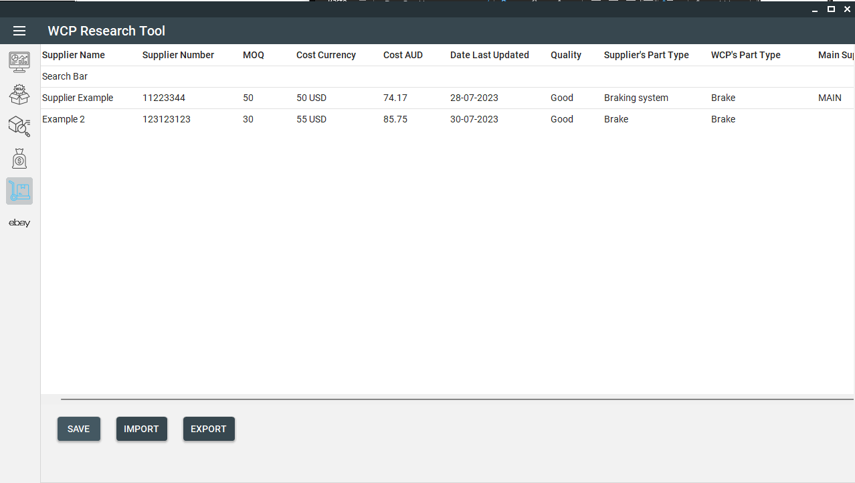

Alternative Index Detail Tab Rough Mock Up Design version 2.1

|  |  |  |  |  |
| --- | --- | --- | --- | --- |
| **Column Name** | **Importable** | **Editable** | **Source** | **note** |
| supplier Number (s) | Y | Y | Pinnacle |  |
| MOQ | Y | N | Import |  |
| cost currency (from supplier details) | Y | N | Import |  |
| cost AUD | N | Y | Calculated | Calculated from cost currency |
| date last updated | N | N | Generated |  |
| Quality | N | Y | Manual | Good/normal/bad |
| Supplier’s part type | Y | N | Import |  |
| WCP’s part type | Y | N | Import | Input from Form |
| Main Supplier | N | Y | Manual | Only one supplier can be the main supplier |

Table of Column in Alternative Index Detail Tab

* Data will be based on the product selected on the Product Page
* ***Cost AUD will be calculated using currency conversion???***
* Data that will be linked:
  + Supplier : product (many to many)
    - Will have a main supplier. May be tagged in database and shown in table.

## eBay Compatibility Tab

eBay Compatibility Tab Rough Mock Up Design version 2.1

|  |  |  |  |
| --- | --- | --- | --- |
| **Column Name** | **Importable** | **Editable** | **Source** |
| k type s | N | Y | Manual |

Table of Column in eBay Compatibility Tab’s K Types Table

**NOTE: Need a full name for K-type**

|  |  |  |  |
| --- | --- | --- | --- |
| **Column Name** | **Importable** | **Editable** | **Source** |
| EPID s | N | Y | Manual |

Table of Column in eBay Compatibility Tab’s EPIDs Table

**NOTE: Need a full name for EPID**

* Data will be based on the product selected on the Product Page
* Not used on Launch
* To be decided
* Manual inputs
* Able to export

# Future Requirements

This section will be about the future requirements that will be continued after the initial/priority requirement of this project are finished beforehand.

## Import/Export Tool

This tool would import an invoice from a supplier in a per shipment basis. This wool would be able to:

* Calculates the indeed cost (based of currency and shipping cost) that WCP currently do this in excel (*sample will be given soon*)
* Using the supplier number in the invoice/manually input, the tool can add the following info:
  + WCP SKU number,
  + Pinnacle part type,
  + IC number,
  + IC description

to the products available in the invoice.

* Export a list that can be used by the warehouse team to use it to create receipt stock that contains the supplier part number ,WCP SKU number, part type ,IC description, and quantity.
  + (Does the tool also create the receipt stock? Or is it done by the warehouse team and their system?)
* Export a data entry sheet to be entered into the pinnacle system that contains the following information:
  + Supplier part number,
  + WCP SKU number,
  + Pinnacle Part type,
  + IC description,
  + Quantity,
  + IC number,
  + Landed Cost